**Coyote Creek Youth Sports**

**Pop Warner  
www.ccys.com**

**P.O. Box 730279**

**San Jose, CA 95173**

**(408) 857-6699**

**408.857-6699**

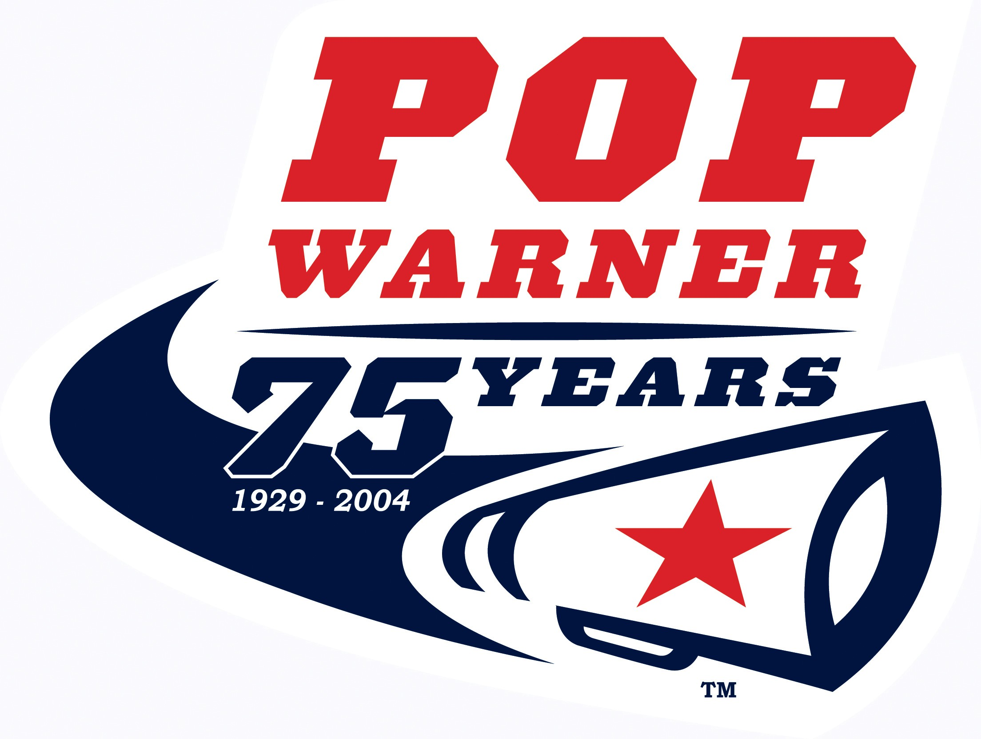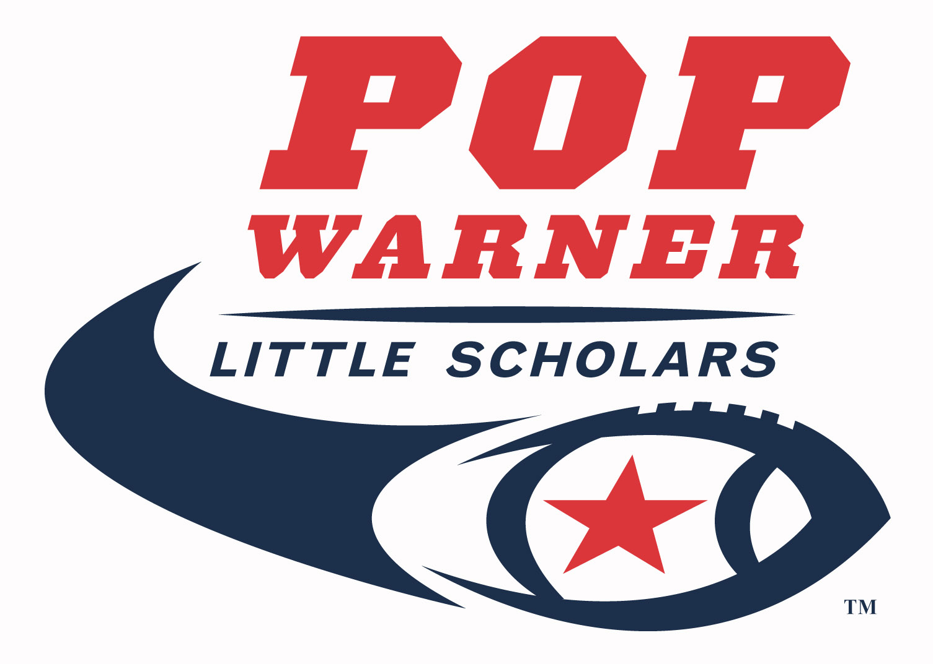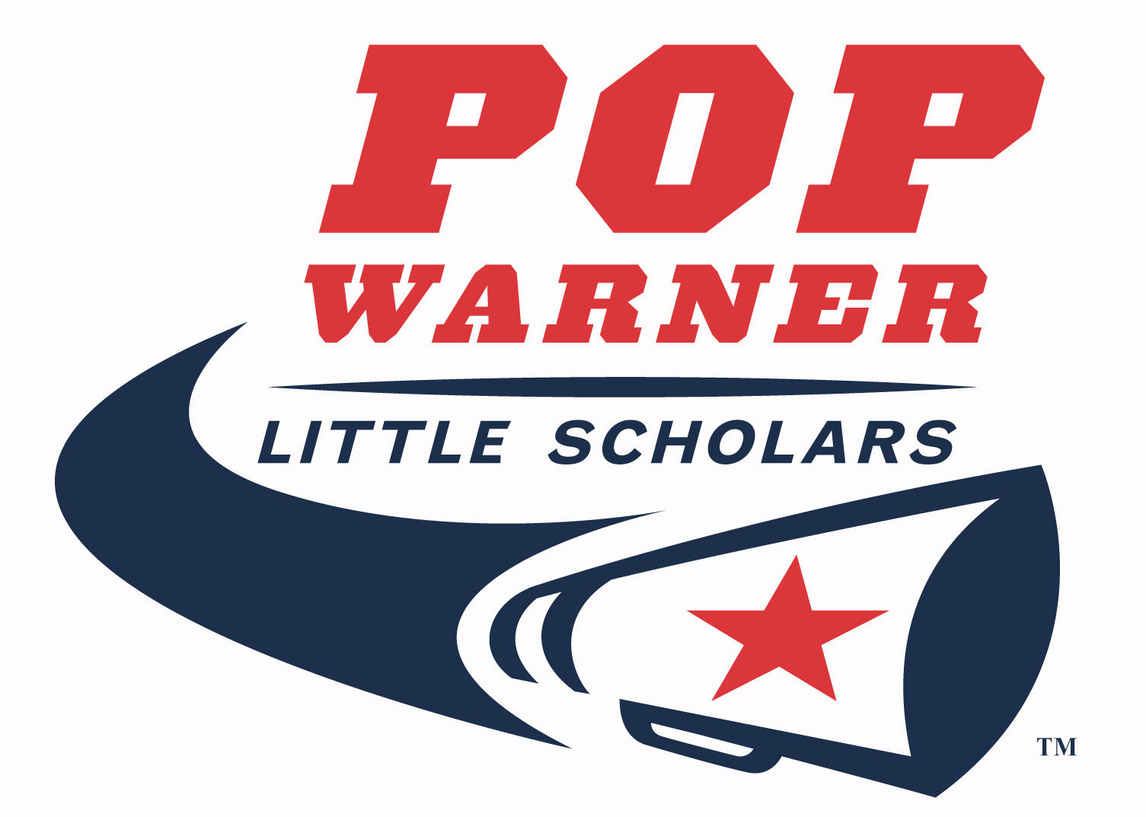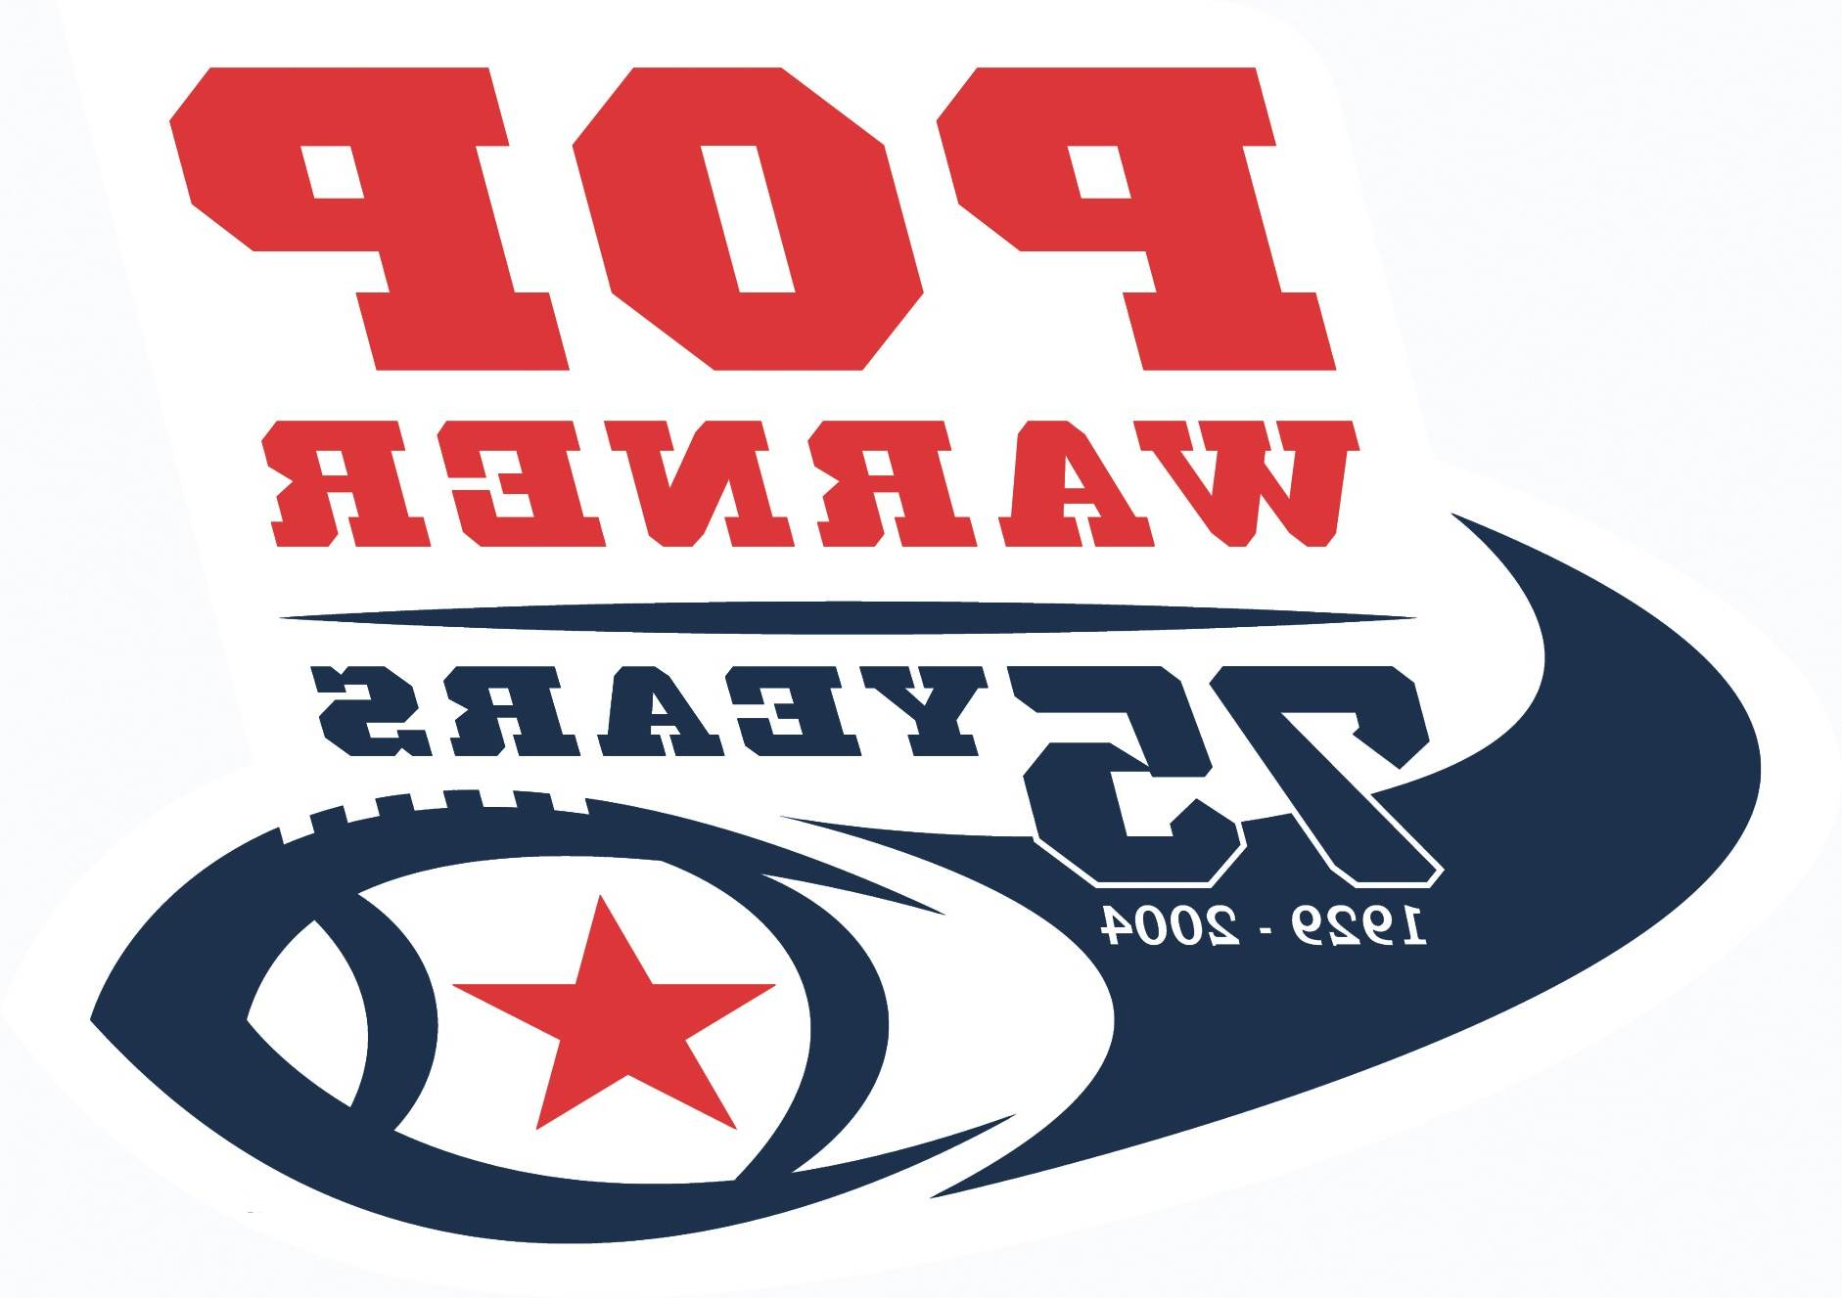

**Welcome to Coyote Creek Youth Sports**

**Below is a list of general information that will help you prepare for the upcoming 2022 football and cheerleading season.**

**Practice Sessions**:

All practice sessions will be held on the football field at Yerba Buena High School. Football and Cheer practice begins **Monday, August 1, 2022,** from 6:00pm -8:30pm. The preseason practice schedule is listed below. During the regular season beginning August 29th, practices will be on Tuesday, Wednesday, and Thursday from 6:00pm – 8:00pm.

**Divisional Ages: (Note: Players no longer have a weight requirement, Players of any weight may participate as long as they are no older than the ages specified below:** **Age are as of July 31, 2022**

## **Division Age Football Head Coach Cheer Head Coach**

6 U(Flex) Ages 5-6 Yoni Zamaniego Tiny Mite (5-6) Mikayla Laury

8 U Ages 7-8 Orlando Cabrera Junior Pee Wee (8-9-10) TBD

10 U Ages 8-9-10 TBD.

12 U Ages 10-11-12 David Plunkett, Jr Junior Varsity(11-12-13)

14 U Ages 12-13-14 Andre Hunt Joyel

**CCYS Joint Combine on Opening Day – August 1st:**

On Opening Day, CCYS will conduct a joint practice session. This session will be a combined practice involving all four football and all three cheer divisions. This practice will be held on the main field. We will have a number of special activities for our players, cheerleaders and parents designed to build camaraderie and unity in our program. It is important that parents plan to attend this special practice.

***Note: Practices on Monday, August 1st thru Thursday, August4th will be non-contact conditioning practices. All football players must have at least 10 hours of non-contact conditioning practice prior to participation in contact practice.***

|  |  |  |  |  |  |  |  |
| --- | --- | --- | --- | --- | --- | --- | --- |
| Practice Schedule | Sunday | Monday | Tuesday | Wednesday | Thursday | Friday | Saturday |
| 8/1 - 8/6 | **n/a** | **6:00pm** | **6:00pm-8:30pm** | **6:00pm-8:30pm** | **6:00pm-8:30pm** |  |  |
| 8/7 - 8/13 | **n/a** | **6:00pm-8:30pm** | **6:00pm-8:30pm** | **6:00pm-8:30pm** | **6:00pm-8:30pm** | **n/a** | **n/a** |
| 8/14-8/20 | **n/a** | **6:00pm-8:30pm** | **6:00pm-8:30pm** | **6:00pm-8:30pm** | **6:00pm-8:30pm** | **n/a** | **CCYS Scrimmage**  **@SJSU** |
| 8/21-8/27 | **n/a** | **6:00pm-8:30pm** | **6:00pm-8:30pm** | **6:00pm-8:30pm** | **6:00pm-8:30pm** | **n/a** | **PPWLS Official Certification** |
| 8/28-9/3 | **Pop Warner**  **Jamboree** | **n/a** | **6:00pm-8:00pm** | **6:00pm-8:00pm** | **6:00pm-8:00pm** | **n/a** | **TBA** |

***\*Note: CCYS will have a preseason scrimmage on Saturday, August 20th at the San Jose State practice fields. The first regular season game will be Labor Day weekend, Saturday or Sunady, September 3rd or 4th***

**Equipment Use Fee/Practice Attire:**

All fees are due at equipment distribution on July 31st but no later than Monday, August 1st . Prompt payment of fees enables Coyote Creek to meet its financial obligations.  **No protective gear will be issued until the fees have been paid; there are absolutely no exceptions**. Players will be required to provide their own girdle with pads

Practice attire necessary for the conditioning practice sessions consists of Helmut, practice jersey, sweatpants or shorts and cleats.

**Equipment distribution:** Equipment will be issued at the CCYS Equipment Shed on the practice field at Yerba Buena High School to fully paid roster players on **Sunday, July 31st , 8:30am – 12:00pm on a first come first served basis.** Roster players are the first thirty-five players (16 on 6U) registered to a team.

Cheer participants will be required to make a **$150.00** cheer uniform deposit no later than July 16, 2022, at cheer uniform fitting. The cheer uniform deposit will be deducted from the total fee due.

***\*All fees are nonrefundable.***

**Sports Physical**:



A **Sports Physical** certifying the player or cheerleader to participate in a contact sport or in cheerleading is required prior to participation by any football player (contact or non-contact) or cheerleader in any practice. A physical must be obtained by **August 1st*.*** If you have health care coverage through an HMO or a PPO, such as Kaiser, etc., you may use your own physician. However, you must take the Medical Examination Release Form to your physician. If you need the form, it can be obtained from the [www.ccys.com](http://www.ccys.com) website. **Dr. Chris Chung will be available for sport physicals** on **Sunday, July 31st 9:00 am – 12:00pm on the practice field at** Yerba Buena High School at a cost of $25.00 per person. Physicals are on a first come-first serve basis.

**Birth Certificate/Photo**:

Copies of the original birth certificates are required to be certified by Bay Area Pop Warner. Only certified players can participate in official Bay Area Pop Warner Conference games. If you were not born in Santa Clara County and do not have a certified original birth certificate copy, you should immediately send for a certified copy from the county or country that you were born in. This is absolutely necessary for certification and participation in Bay Area Pop Warner conference games. **So don’t delay!** *A current photograph is required. Wallet size is preferred*: no Polaroid’s.

**Pop Warner Scholastic Program:** Please submit to your team manager a copy of your child’s ***report card (2021- 22 full year)*** for the *school year ending 2022.* Report cards are necessary for the PW Little Scholar application that must be submitted by CCYS for each child that participates in our program and is mandatory. This is used for player / cheerleader play-off eligibility and scholastic recognition. If your child has a Grade Point Average below 2.0, you will have to complete a Scholastic Eligibility Form in order for child to participate and submit a valid progress report prior to October 1, 2022.

**All required documentation listed above is due no later than August 1, 2022**

**PPWLS Official Certification:**



PPWLS Official Certification will be held ***Sunday,*** ***August 28th.***

**There will be a mandatory CCYS Parents meeting at Yerba Buena HS at 7:00pm on Monday, August 1, 2022. At least one parent or guardian is required to attend. This meeting will allow parents to receive answers to your questions about our program. Parents will also receive their volunteer assignments. Please remember that every parent is required to volunteer at least 10 hours per season in order for your child to participate in our program. In addition, parents should plan to submit all required documentation (birth certificate, report card, photo and physical) no later than August 1, 2022.**

Sincerely Yours,

***The Board and Staff of Coyote Creek Youth Sports***